Post-Offer Self-Identification Form
Virginia Commonwealth University (VCU) is committed to equal employment opportunity in all matters of employment (such as hiring, promotion, transfer, training, layoff, compensation, fringe benefits, and termination), regardless of race, color, religion, national or ethnic origin, age, sex (including pregnancy), political affiliation, veteran status, family medical and genetic information, sexual orientation, gender identity, gender expression, disability, or any other status protected by law.
As a government contractor, VCU is subject to governmental recordkeeping and reporting requirements for the administration of civil rights laws and regulations. Specifically, VCU is subject to Executive Order 11246 (as amended), Section 503 of the Rehabilitation Act of 1973 (as amended), and the Vietnam Era Veterans’ Readjustment Assistance Act of 1974 (as amended). These laws require us to take affirmative action to employ and promote qualified women, minorities, individuals with disabilities, and protected veterans.
To comply with these laws, we invite employees to voluntarily self-identify their race, ethnicity, sex, veteran status, and disability status. Refusing to provide this information will not result in any adverse treatment. We will use this information only in ways that are consistent with our obligations under affirmative action and equal employment opportunity laws.
The information you submit is confidential, except that we may inform supervisors and managers of disability-related work restrictions and accommodations; we may inform first aid and safety personnel in appropriate circumstances of conditions that might require emergency treatment; and we may inform government officials in the context of enforcing affirmative action and other employment laws.
Under our affirmative action program, we carefully consider the job qualifications of all applicants and employees when filling job openings and selecting people for training. VCU periodically reviews its personnel processes to ensure that women, minorities, individuals with disabilities, and protected veterans are not stereotyped in a manner that limits their access to jobs for which they are qualified. If a disability prevents an employee from performing the essential functions of his or her job, the university engages in an interactive process to search for a reasonable accommodation that will allow the person to perform the essential functions of the job.

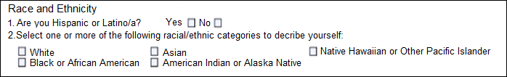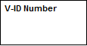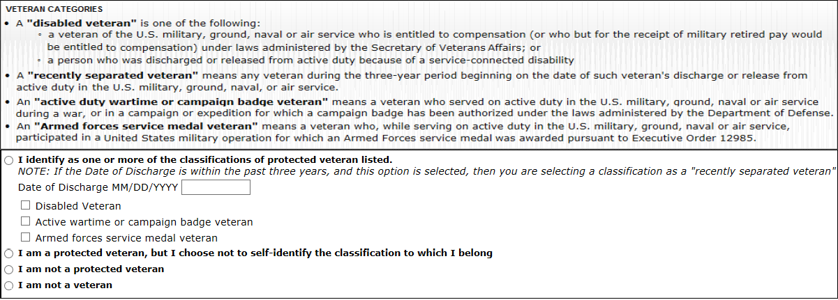
Self-Identification
Legal Sex
Male Female
I do not wish to answer

Voluntary Self-Identification of Disability
Form CC-305 OMB Control Number 1250-0005
Page 1 of 1 Expires 05/31/2023
Name: Date:

Employee ID:
(if applicable)
Why are you being asked to complete this form?
We are a federal contractor or subcontractor required by law to provide equal employment opportunity to qualified people with disabilities. We are also required to measure our progress toward having at least 7% of our workforce be individuals with disabilities. To do this, we must ask applicants and employees if they have a disability or have ever had a disability. Because a person may become disabled at any time, we ask all of our employees to update their information at least every five years.
Identifying yourself as an individual with a disability is voluntary, and we hope that you will choose to do so. Your answer will be maintained confidentially and not be seen by selecting officials or anyone else involved in making personnel decisions. Completing the form will not negatively impact you in any way, regardless of whether you have self-identified in the past. For more information about this form or the equal employment obligations of federal contractors under Section 503 of the Rehabilitation Act, visit the U.S. Department of Labor’s Office of Federal Contract Compliance Programs (OFCCP) website at www.dol.gov/ofccp.

How do you know if you have a disability?
You are considered to have a disability if you have a physical or mental impairment or medical condition that substantially limits a major life activity, or if you have a history or record of such an impairment or medical condition. Disabilities include, but are not limited to:
- Autism | - Deaf or hard of hearing | - Missing limbs or partially missing limbs
- Autoimmune disorder, for example, lupus, fibromyalgia, rheumatoid arthritis, or HIV/AIDS | - Depression or anxiety | - Nervous system condition, for example, migraine headaches, Parkinson’s disease, or Multiple sclerosis (MS)
- Blind or low vision | - Diabetes | - Psychiatric condition, for example, bipolar disorder, schizophrenia, PTSD, or major depression
- Cancer | - Epilepsy
- Cardiovascular or heart disease | - Gastrointestinal disorders, for example, Crohn’s Disease, or irritable bowel syndrome
- Celiac Disease | - Intellectual disability
- Cerebral palsy

Please check one of the boxes below:
☐ Yes, I Have A Disability, Or Have A History/Record Of Having A Disability
☐ No, I Don’t Have A Disability, Or A History/Record Of Having A Disability
☐ I Don’t Wish To Answer
PUBLIC BURDEN STATEMENT: According to the Paperwork Reduction Act of 1995 no persons are required to respond to a collection of information unless such collection displays a valid OMB control number. This survey should take about 5 minutes to complete.

For Employer Use Only
Employers may modify this section of the form as needed for recordkeeping purposes.
For example:
Job Title: _______________ Date of Hire: _______________

Voluntary Self-Identification of Disability

Form CC-305 OMB Control Number 1250-0005
Expires 05/31/2023
Page 2 of 2

Reasonable Accommodation Notice

Federal law requires employers to provide reasonable accommodation to qualified individuals with disabilities. Please tell us if you require a reasonable accommodation to apply for a job or to perform your job. Examples of reasonable accommodation include making a change to the application process or work procedures, providing documents in an alternate format, using a sign language interpreter, or using specialized equipment.

i Section 503 of the Rehabilitation Act of 1973, as amended. For more information about this form or the equal employment obligations of Federal contractors, visit the U.S. Department of Labor’s Office of Federal Contract Compliance Programs (OFCCP) website at www.dol.gov/ofccp.

PUBLIC BURDEN STATEMENT: According to the Paperwork Reduction Act of 1995 no persons are required to respond to a collection of information unless such collection displays a valid OMB control number. This survey should take about 5 minutes to complete.

